Suggested solution to assignment 1

Chapter 1
- Indicate which of the following variables are quantitative and which are qualitative.
- Number of children under 18 years of age in a family
- Colors of cars
- Salaries of Football Players
- Time to commute from home to work
- Number of errors in a person’s credit report

Answer: a. Quantitative b. Qualitative c. Quantitative d. Quantitative e. Quantitative

- Classify each of the following qualitative variables as ordinal or nominative. Explain your answers.
Qualitative Variables Categories
Statistics course letter grade A B C D F
Door choice on Let’s Make A Deal Door﹟1 Door﹟2
Television show classification TV-G TV-PG TV-14 TV-MA
Personal computer ownership Yes No
Restaurant rating ***** **** *** ** *
Incoming tax filing status Married filing jointly; Married filing separately; Single; Head of household; Qualifying widow(er)

Answer: Ordinal; there is a meaningful ordering in the course letter grade. A is better than B, B is better than C, and so on……
Nominative; there is no meaningful ordering of the door choice.
Ordinal; there is meaningful ranking between Television show.
Nominative; there is no ordering between “Yes” and “No”
Ordinal; five stars restaurant is better than four stars restaurant, four stars is better than three stars, and so on……
Nominative; there is no ordering between the tax filing status.

- True / False Questions
- A population is a set of existing units. ( )
- If we examine some of the population measurements, we are conducting a census of the population. ( )
- A quantitative variable can also be referred to as a categorical variable. ( )
- Statistical inference is the science of using a sample of measurements to make generalizations about the important aspects of a population of measurements. ( )
- The science of describing the important aspects of a set of measures is called statistical inference. ( )
Ans: a. TRUE b. FALSE c. FALSE d. TRUE e. FALSE

Chapter 2
- The following data show the method of payment by 18 customers in a supermarket checkout line. Here, C refers to cash, CK to check, CC to credit card, and D to debit card, and O stands for other.

C CK CK C CC D O CC D
CK CC D CC C CK CK O D

- Construct a table giving frequency distribution, relative frequency distribution and percent frequency distribution.
- Draw a bar chart for the frequency distribution.
- Draw a pie chart for the percent frequency distribution.
Ans: a.
Method of Payment | Frequency | Relative  frequency | Percent frequency
C | 3 | 0.167 | 16.7%
CK | 5 | 0.278 | 27.8%
CC | 4 | 0.222 | 22.2%
D | 4 | 0.222 | 22.2%
O | 2 | 0.111 | 11.1%
b.
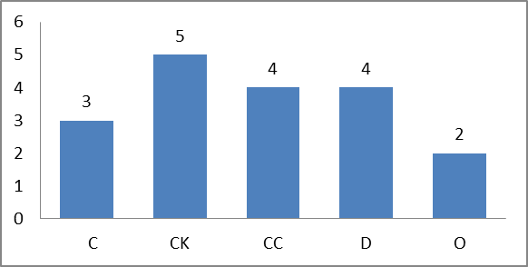
c.
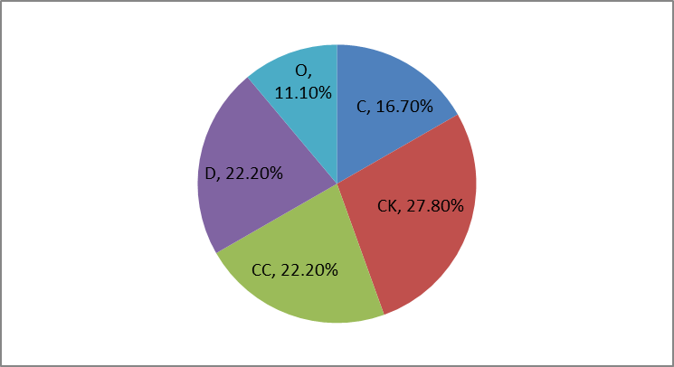

- THE MARKETING RESEARCH CASE
60 randomly selected shoppers have rated a new bottle design for a popular soft drink. The data are given below.
34 | 33 | 33 | 29 | 26 | 33 | 28 | 25 | 32 | 33
32 | 25 | 27 | 33 | 22 | 27 | 32 | 33 | 32 | 29
24 | 30 | 20 | 34 | 31 | 32 | 30 | 35 | 33 | 31
32 | 28 | 30 | 31 | 31 | 33 | 29 | 27 | 34 | 31
31 | 28 | 33 | 31 | 32 | 28 | 26 | 29 | 32 | 34
32 | 30 | 34 | 32 | 30 | 30 | 32 | 31 | 29 | 33

a. Find the number of classes that should be used to construct a frequency distribution and histogram for the bottle design ratings.
b. If we round up to the nearest whole rating point, show that we should employ a class length equal to 3.
c. Define the non-overlapping classes for a frequency distribution, tally the number of ratings in each class and develop a frequency distribution.
d. Draw the frequency histogram for the ratings data, and describe the distribution shape.
Ans:
a. n = 60, = 32< n,= 64 > n, then the number of classes should be 6.
b. Class Length = (35 – 20) / 6 = 2.5 and we round it up to 3.
c.
 |  | class | frequency
20 | < | 23 | 2
23 | < | 26 | 3
26 | < | 29 | 9
29 | < | 32 | 19
32 | < | 35 | 26
35 | < | 38 | 1

d.
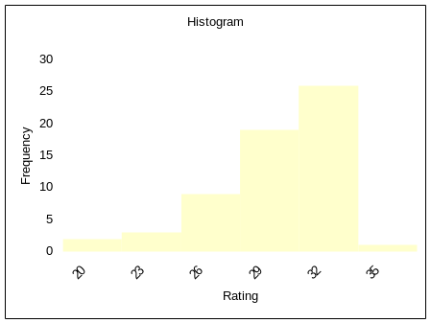
Distribution shape is left skewed.

6. The following data consist of sales figures (in millions of dollars) for a group of 20 firms. Construct a stem-and-leaf display for these data. Use a leaf unit equal to 100.
6835 | 3517 | 1973 | 1449 | 2820 | 2384 | 5358 | 1376 | 1233 | 1725
3291 | 6047 | 2707 | 7903 | 3291 | 4616 | 2675 | 1541 | 3707 | 4189
Ans:
Rounding each measurement to the nearest hundred yields the following stem & leaf

Stem unit = 1000, Leaf Unit = 100
Frequency | Stem | Leaf
5 | 1 | 2 4 4 5 7
5 | 2 | 0 4 7 7 8
4 | 3 | 3 3 5 7
2 | 4 | 2 6
1 | 5 | 4
2 | 6 | 0 8
1 | 7 | 9
Total 20

- THE TRASH BAG CASE
Figure 2.22 gives a stem-and-leaf display of 40 breaking strengths in the trash bag case.
a. Use the stem-and-leaf display to describe the distribution of breaking strengths.
b. Write out the 5 smallest breaking strengths as they would be expressed in the original data.
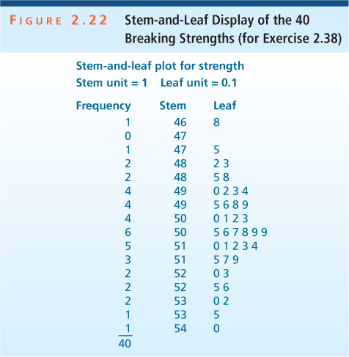
Ans: a. Distribution is symmetric
b. 46.8, 47.5, 48.2, 48.3, 48.5.
8. Back-to-back stem-and-leaf displays can be used to compare the distribution of a variable for two different groups. Consider the following data, which give the alcohol content by volume (%) for different beers produced by the Flying Dog Brewery and the Sierra Nevada Brewery, followed by a back-to-back stem-and leaf display.
Flying Dog Brewery:
4.7 4.7 4.8 5.1 5.5 5.5 5.6 6.0 7.1
7.4 7.8 8.3 8.3 9.2 9.9 10.2 11.5
Sierra Nevada Brewery:
4.4 5.0 5.0 5.6 5.6 5.8 5.9 5.9 6.7 6.8 6.9
7.0 9.6
Leaf units at 0.1
 | 8 | 7 | 7 | 4 | 4
6 | 5 | 5 | 1 | 5 | 0 | 0 | 6 | 8 | 9 | 9
 |  |  | 0 | 6 | 7 | 8 | 9
 | 8 | 4 | 1 | 7 | 0
 |  | 3 | 3 | 8
 |  | 9 | 2 | 9 | 6
 |  |  | 2 | 10
 |  |  | 5 | 11

a. What would you consider to be a median alcohol content of beers made by each of the two breweries?
b. Does one brewery tend to have higher alcohol content in its beer than the other brewery? If so, which one? Explain how you reach this conclusion by using the stem-and-leaf display.
c. Do alcohol content distributions for the two breweries appear to have the same levels of variability? Explain how you reach this conclusion by using the stem-and-leaf display.
Ans: a. Flying Dog Brewery: 7.1
Sierra Nevada Brewery: 5.9
b. Yes, Flying Dog Brewery tends to have higher alcohol content of beers.
Flying Dog Brewery has more alcohol content of beers from 7.0 to 11.5.
c. No, they have different levels of variability. Flying Dog Brewery has a wide range of alcohol content of beers from 4.7 to 11.5, while Sierra Nevada Brewery has most alcohol content of beers concentrated from 4.4 to 7.0.

9. Fill in the missing components of the following frequency distribution constructed for a sample size of 50.
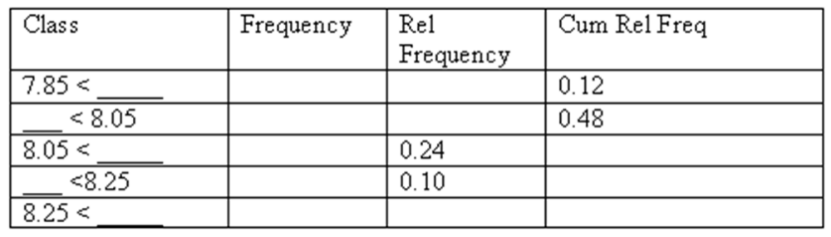
Ans:
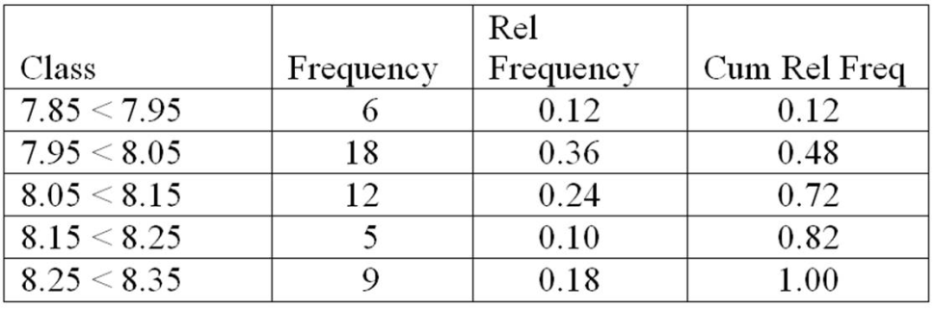
10. Figure 2.38 was used in various Chevrolet magazine advertisements in 1997 to compare the overall resale values of Chevrolet, Dodge, and Ford trucks in the years from 1990 to 1997. What is somewhat misleading about this graph?
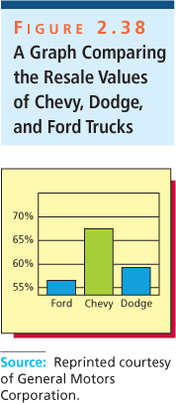
Ans: The graph indicates that Chevy trucks far exceed Ford and Dodge in terms of resale value, but the y-axis scale is misleading.

